**ME220 Engineering Design and Innovation**

**Introduction Reverse Engineering: Product Decomposition**

E N0: E/19/256

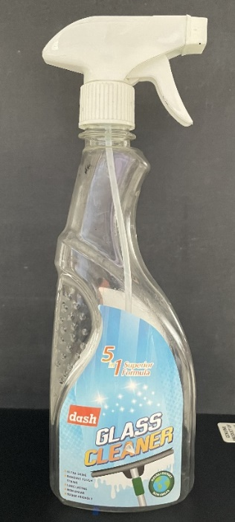

**Figure 1: Handheld sprayer**

**Decomposition into its subsystems**

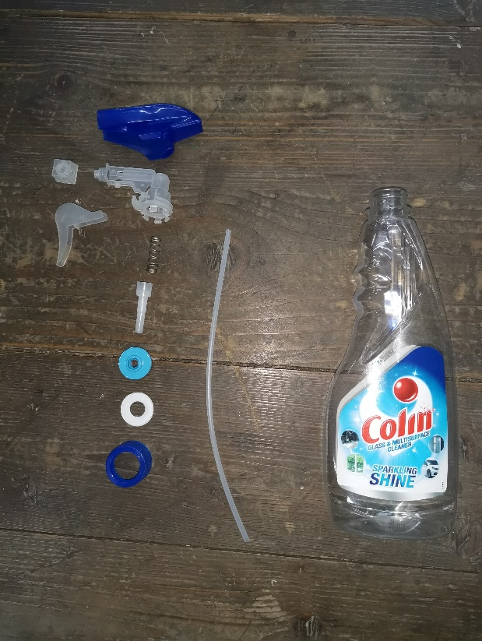

**Figure 2: Handheld sprayer decomposition into its subsystems**

**Parts List**

|  |  |  |  |  |  |
| --- | --- | --- | --- | --- | --- |
| **Part**  **#** | **Description** | **Qty** | **Function** | **Material/Manufacturing Process** | **Photo** |
| **Sub-system 1: Ejecting Mechanism** | | | | | |
| 001 | Handle | 1 | Added the pressure on to the piston | Plastic |  |
| 002 | Spring | 1 | To refill the cylinder by the fluid after the trigger is released | Steel |  |
| 003 | Valve | 1 | While trigger releasing, fluid flows into the cylinder due to the pressure reduction, through this valve. Due to the one-way valve, fluid can only flow into the cylinder and not the other way. | Plastic |  |
| 004 | Piston | 1 | This contains the cylinder where the fluid is stored temporarily until it released in the next trigger press. This also leads the fluid from the cylinder to the nozzle. | Plastic |  |
| 005 | Suction pipe | 1 | To draws fluid into the piston cylinder | plastic |  |
| 006 | On/Off nozzle | 1 | By rotating, there can be opened or closed the sprayer | plastic |  |
| 007 | Straw insert | 1 | This leads the suction pipe from the bottle to the non-return valve | plastic |  |
| **Sub-system 2: YYY** | | | | | |
| 008 | Bottle | 1 | Fluid is contained in here | Plastic |  |
| 009 | Shell/cover | 1 | To covers plastic casing | plastic |  |
| 010 | Washer | 1 | To seal the bottle and prevents spilling liquid | polystyrene |  |
| 011 | Closure | 1 | To fix the shell and the bottle. Gasket, straw insert are contained in it. | Plastic |  |

**Solid Model of the Handheld Sprayer**

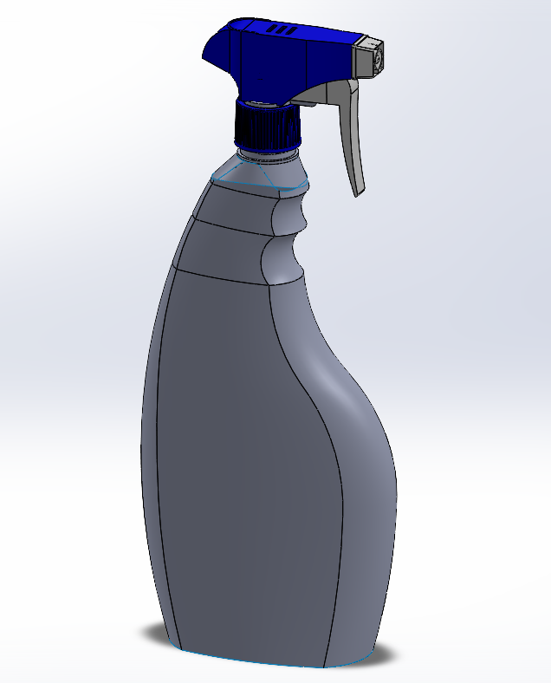

**Figure 3: Solid Model of the Sprayer**

**Exploded View of the Sprayer**

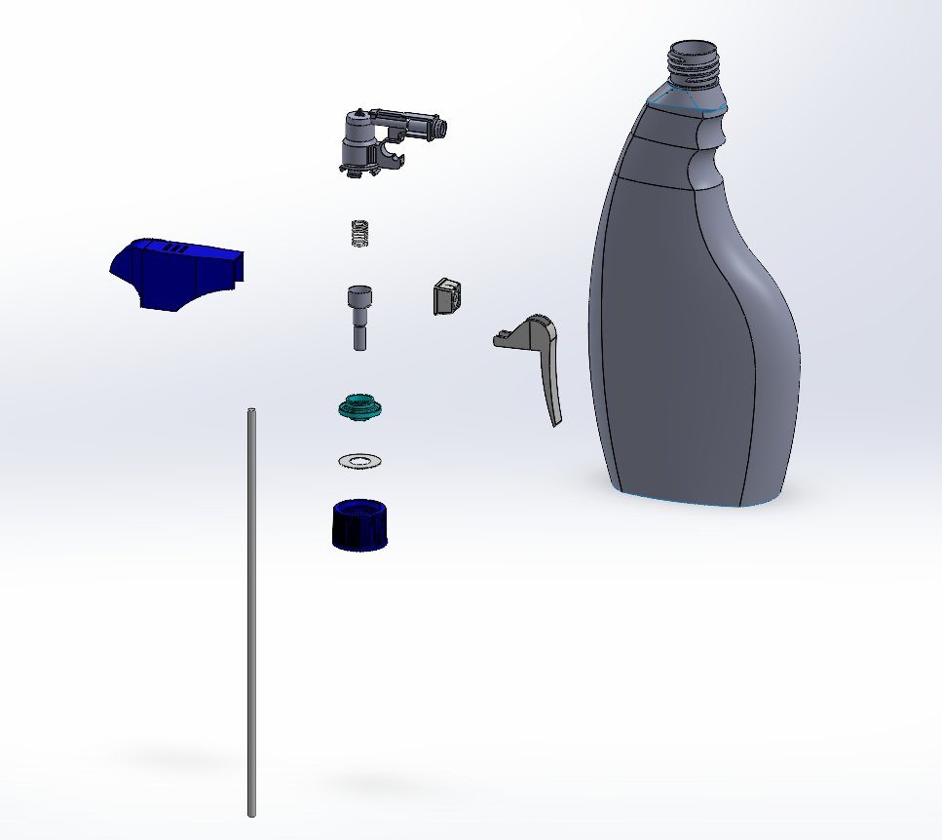

**Figure 4: Configurations of the Handheld Sprayer**

**Figure 5: Solid Model of the Sprayer of 0.5 L and 1 L capacity**

**Recommendation for product improvement**